Data Encoding Class Exercise

Extra Credit

21st April, 2014

AK

HCDE 511

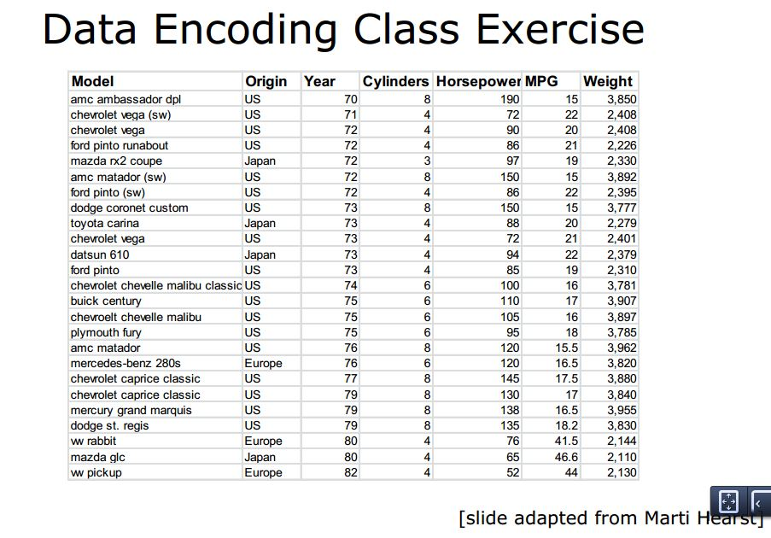

*Fig. 1*

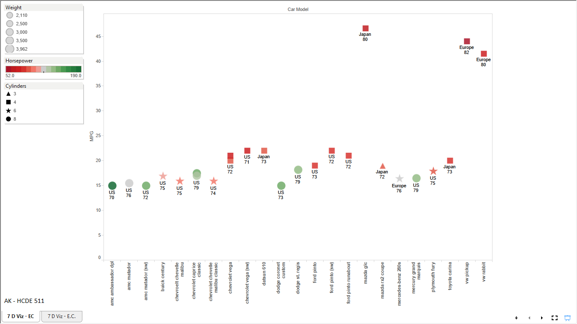

*Fig. 2*

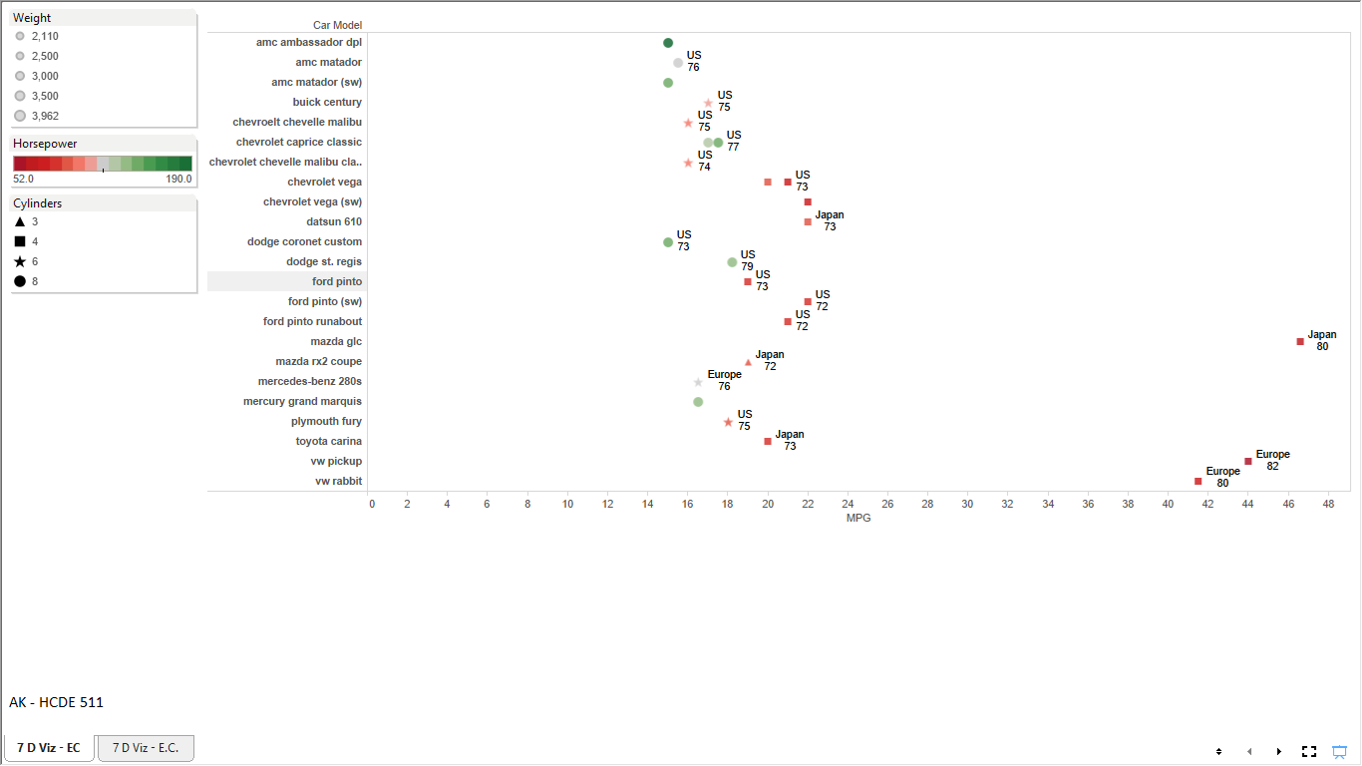

*Fig. 3*

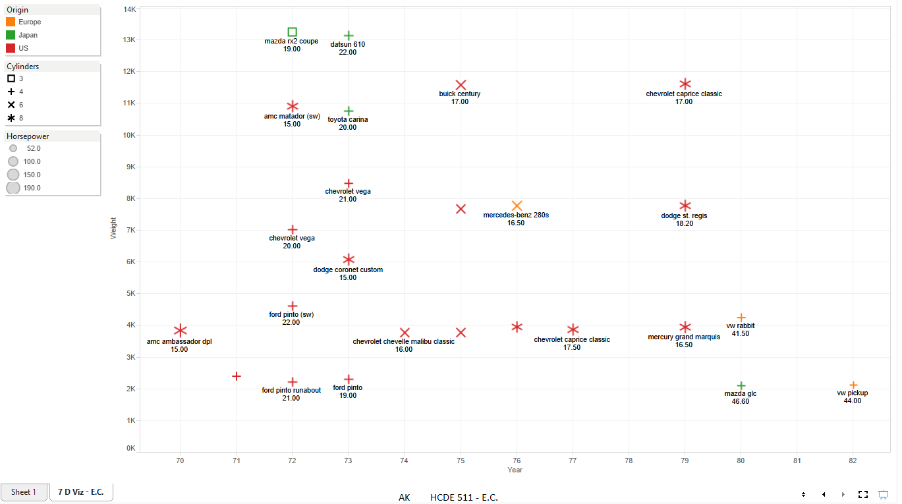

*Fig. 4*